Project Development Phase
Performance Test

Date | 01 October 2026
Team ID | SWTID-2026-4457
Project Name | Script-Controlled ACL – Restrict Record Access Based on Field Value
Maximum Marks

Model Performance Testing:
Project team shall fill the following information in model performance testing template.
S.No. | Parameter | Screenshot / Values
1. | Data Rendered | Custom table Institution Details (u_institution_details) with 6 student records (2 EEE, 2 ECE, 2 CSE). Fields: Student Roll Number, Student Name, Faculty Name, Branch, Email, Phone Number, Description.  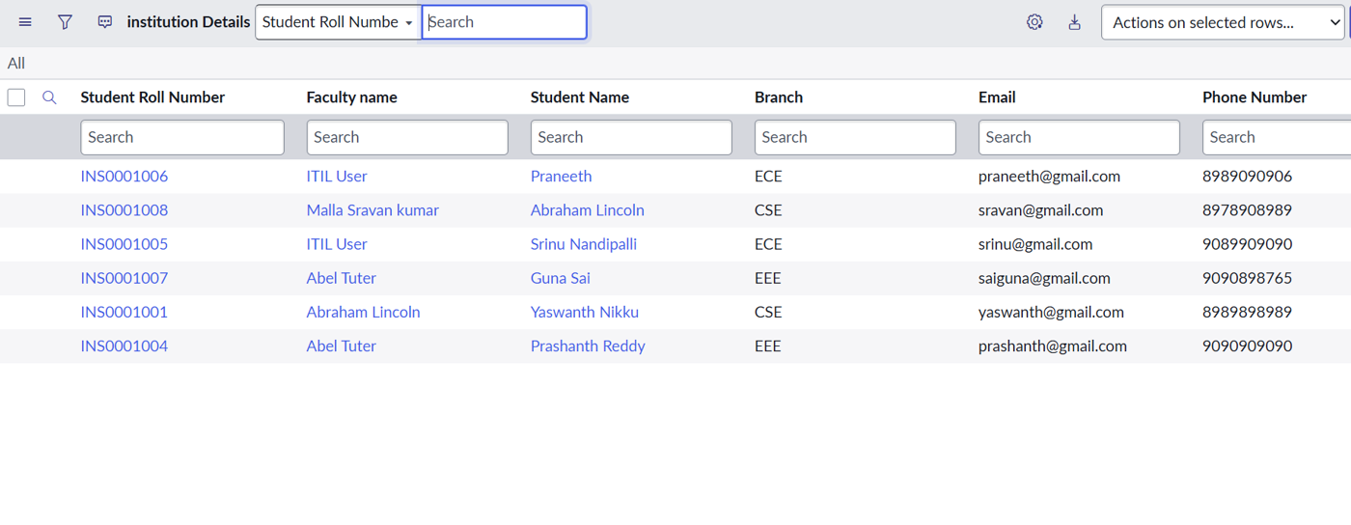  Screenshot: table records list
2. | Data Preprocessing | • Roll Number auto-generated (INS000x) using Auto Number  • Student Name and Faculty Name set as Reference (User) fields  • Branch restricted to a Choice list (ECE, EEE, CSE) for consistent filtering  • Users EEE User and roles bb1, bb2, bb3, bb4 created and assigned  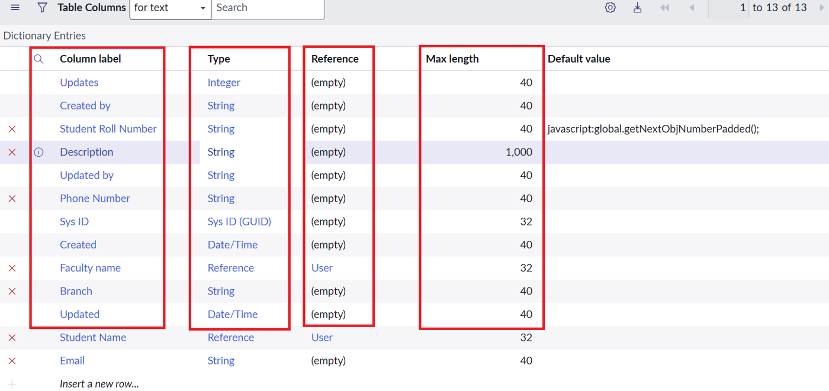  Screenshot: table columns / dictionary entries
3. | Utilization of Filters | ACL Data Condition: Branch is EEE (matches 2 of 6 records). The Read ACL applies only to EEE records, and the role bb1 is required in the Requires role list.  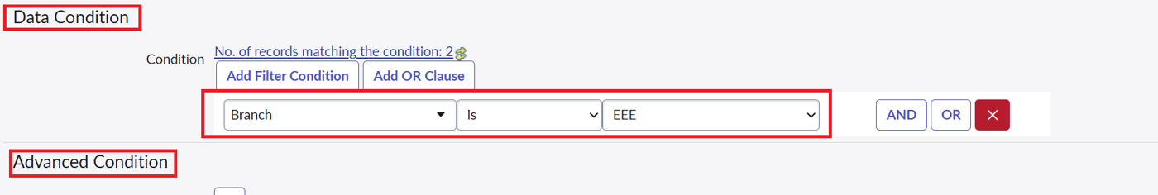  Screenshot: Data Condition on Read ACL
4. | Calculation fields Used | No Tableau calculated fields are used. The equivalent logic is the ACL script, which grants access only when it evaluates to true:  (function () {  if (gs.hasRole('bb1')) {  return true;  } else {  return false;  }  })();  Create, Write and Delete ACLs use roles bb2, bb3 and bb4 with no script.  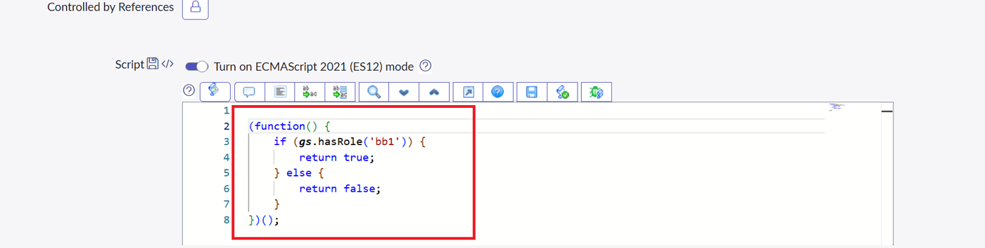  Screenshot: ACL Advanced Condition script
5. | Dashboard design | No of Visualizations / Graphs - 0 graphs; 3 role-based list views (bb1 user: 2 EEE records; user without role: No records to display; Admin: all 6 records).  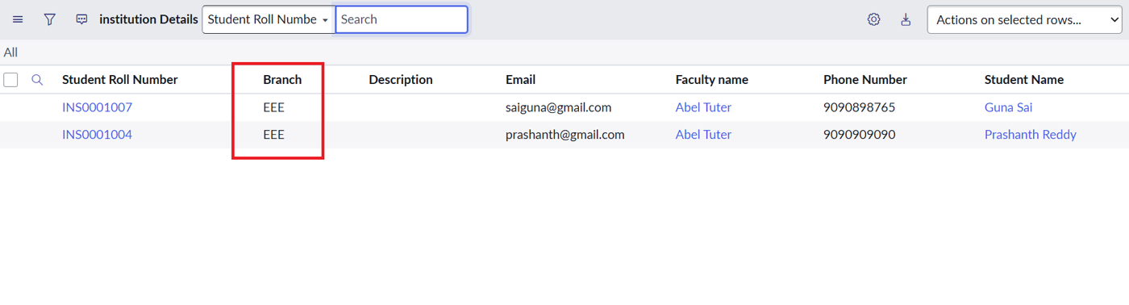  View 1: bb1 user – only the 2 EEE records  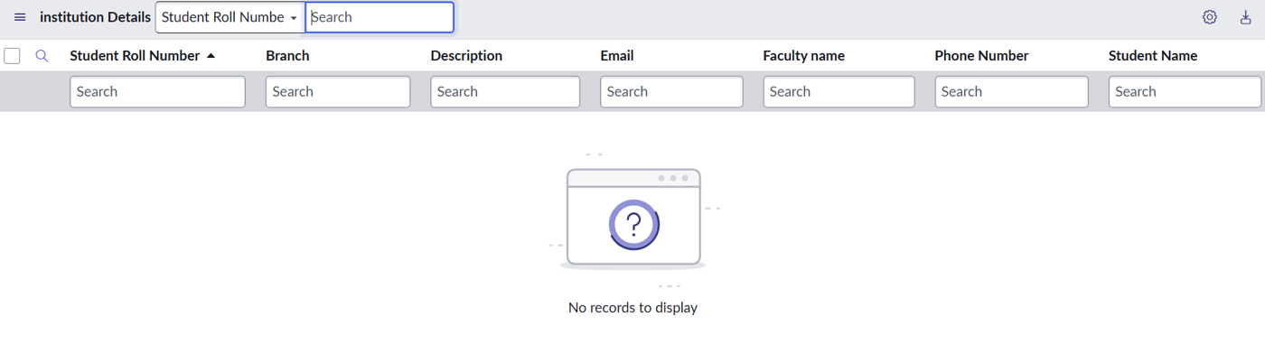  View 2: user without role – No records to display  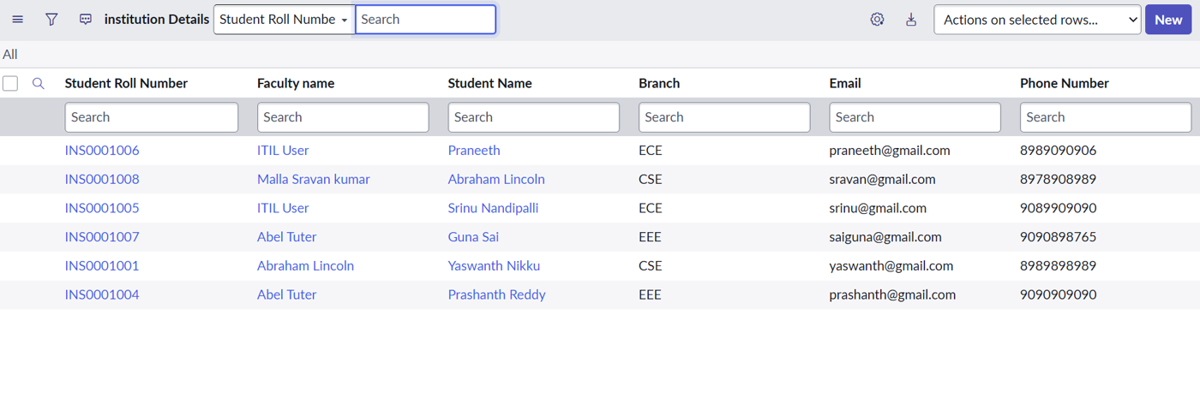  View 3: Admin – all 6 records
6 | Story Design | No of Visualizations / Graphs - 0 graphs; 4 verification results (Read: EEE only; Create: New button for bb2; Write: inline edit for bb3; Delete: confirmation and delete for bb4).  Read verification: bb1 user sees EEE records only  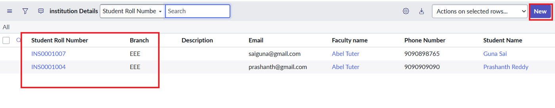  Create verification: New button available for bb2  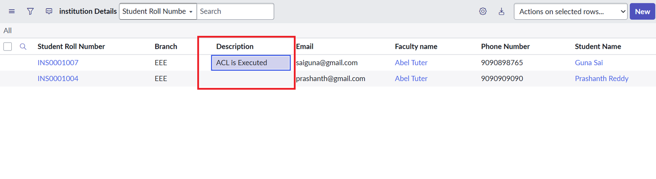  Write verification: inline edit by bb3 (Description updated to "ACL is Executed")  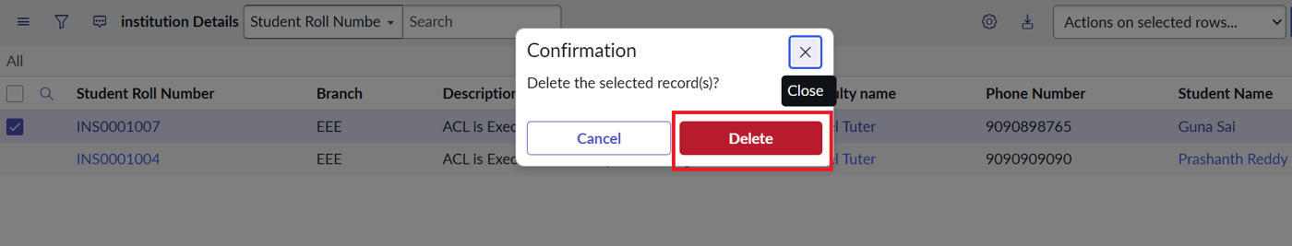  Delete verification: confirmation dialog and delete for bb4

